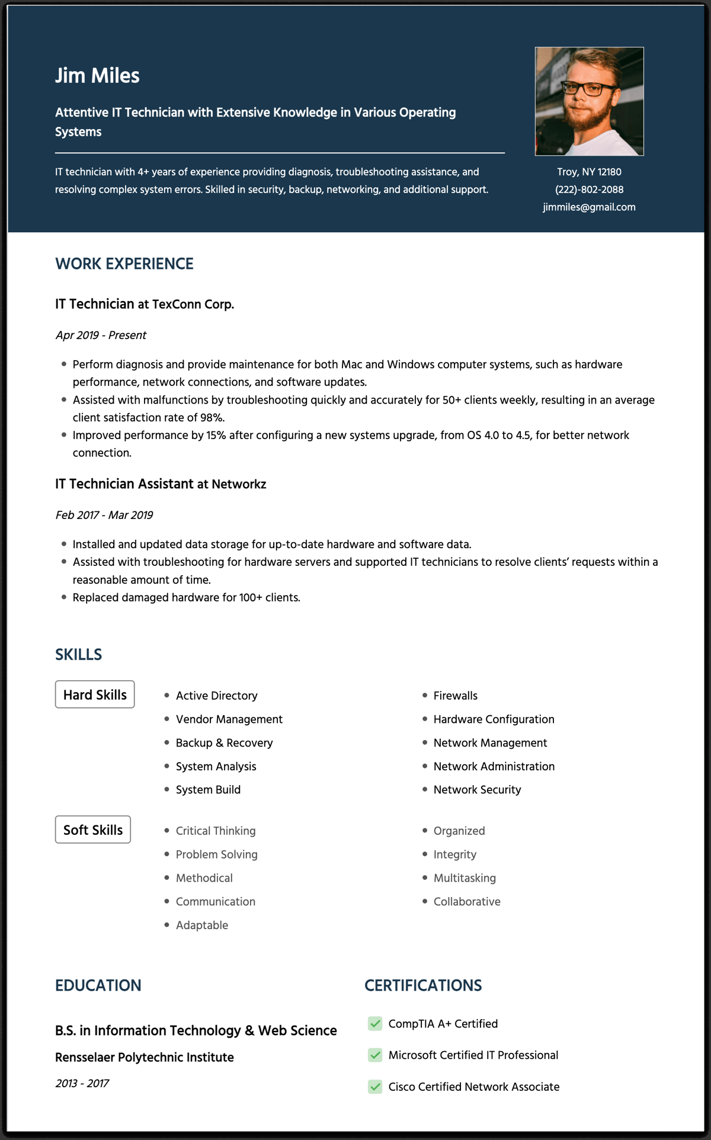
Jim Miles
Attentive IT Technician with Extensive Knowledge in Various Operating Systems
IT technician with 4+ years of experience providing diagnosis, troubleshooting assistance, and resolving complex system errors. Skilled in security, backup, networking, and additional support.
Troy, NY 12180 (222)-802-2088 jimmiles@gmail.com
WORK EXPERIENCE
IT Technician at TexConn Corp.
Apr 2019 - Present
• Perform diagnosis and provide maintenance for both Mac and Windows computer systems, such as hardware performance, network connections, and software updates.
• Assisted with malfunctions by troubleshooting quickly and accurately for 50+ clients weekly, resulting in an average client satisfaction rate of 98%.
• Improved performance by 15% after configuring a new systems upgrade, from OS 4.0 to 4.5, for better network connection.
IT Technician Assistant at Networkz
Feb 2017 - Mar 2019
• Installed and updated data storage for up-to-date hardware and software data.
• Assisted with troubleshooting for hardware servers and supported IT technicians to resolve clients' requests within a reasonable amount of time.
• Replaced damaged hardware for 100+ clients.
SKILLS
Hard Skills
• Active Directory
• Vendor Management
• Backup & Recovery
• System Analysis
• System Build
Soft Skills
• Critical Thinking
• Problem Solving
• Methodical
• Communication
• Adaptable
• Firewalls
• Hardware Configuration
• Network Management
• Network Administration
• Network Security
• Organized
• Integrity
• Multitasking
• Collaborative
EDUCATION
B.S. in Information Technology & Web Science
Rensselaer Polytechnic Institute
2013-2017
CERTIFICATIONS
CompTIA A+ Certified
Microsoft Certified IT Professional
Cisco Certified Network Associate

